Student Name: Michael Newman MIDTERM EXAM CS2400-due October 26th

- Short Answers):
  - (5p. each) The stack pointer points to address 2A8C₍₁₆₎. Show the content of the stack after the sequence of following instructions. Draw a map of the stack after every instruction and show where the stack pointer points to.
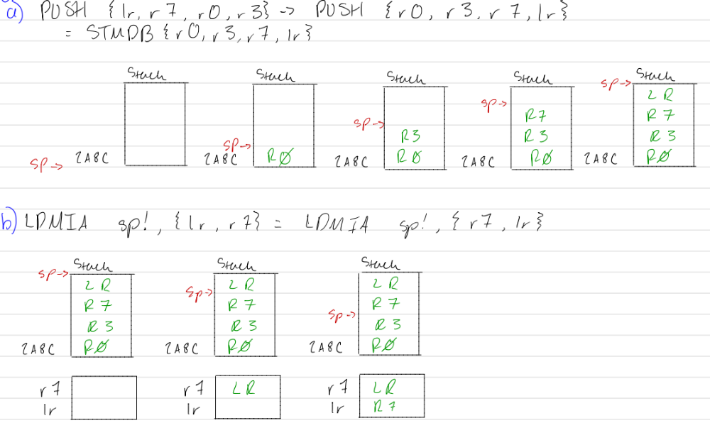
Remark: Remember that PUSH and POP are instruction to store and load to/from a full descending stack.

1.2. (3p. each) Assume an ARM-like CPU but with only 8-bit registers and ALU. In register r0 a byte is stored 1000 0001, in r1-> 0000 0011. The CPU performs the following instruction
RSB r2, r0, r1.
Perform the subtraction and provide the decimal value of the result considering that:
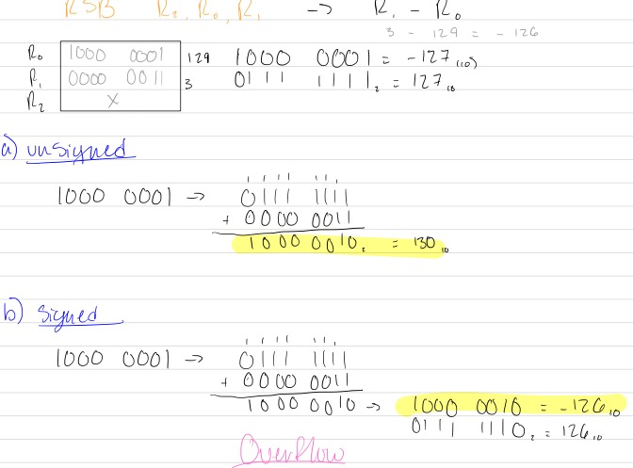

- ARM instructions
Assume that the flags are all initialized to 0. For every of the following instructions separately write the value in the destination register and the flags (3p. each):

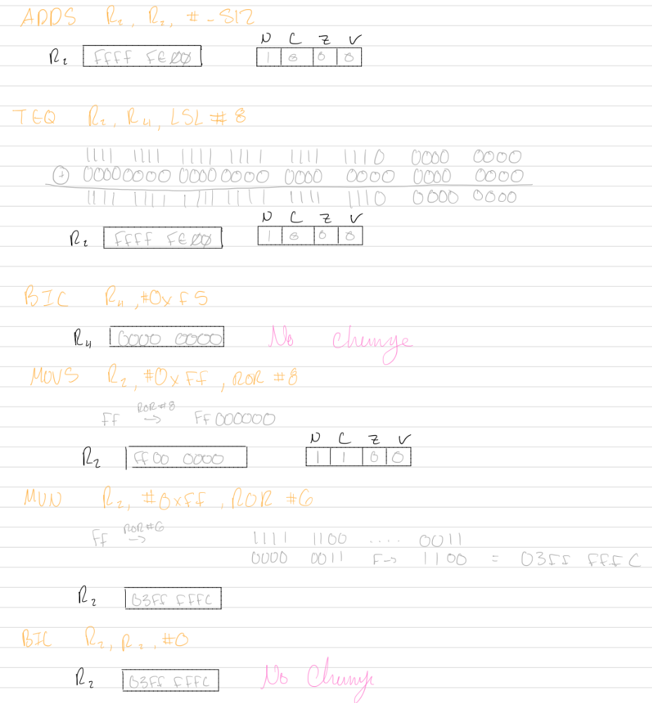

3. ARM assembly:
3.1. (8 p.) Trace the following program and declare which value will be moved to r0. Show the hexadecimal values in registers r0, r5, and r7 after every instruction that changes some of those registers. Show the flags after every instruction that changes the flags.
AREA ExampleA, CODE
ENTRY
start
R0 | 0000 0000 | R5 | 0000 0000 | R7 | 0000 0000 | NZCV | 0000

MOV r0, #102
R0 | 0000 0066 | R5 | 0000 0000 | R7 | 0000 0000 | NZCV | 0000

MOV r5, #0x66
R0 | 0000 0066 | R5 | 0000 0066 | R7 | 0000 0000 | NZCV | 0000

SUB r7, r5, #’A’
R0 | 0000 0066 | R5 | 0000 0066 | R7 | 0000 0025 | NZCV | 0000

CMP r7, #’Z’–‘A’
R0 | 0000 0066 | R5 | 0000 0066 | R7 | 0000 0025 | NZCV | 0010

SUBHI r7, r5, #‘a’
R0 | 0000 0066 | R5 | 0000 0066 | R7 | 0000 0005 | NZCV | 0010

CMPHI r7, #’z’–‘a’
R0 | 0000 0066 | R5 | 0000 0066 | R7 | 0000 0005 | NZCV | 1000

MOVHI r0, #’H’
R0 | 0000 0066 | R5 | 0000 0066 | R7 | 0000 0005 | NZCV | 1000

MOVLS r0, #’F’
R0 | 0000 0046 | R5 | 0000 0066 | R7 | 0000 0005 | NZCV | 1000

MOVEQ r0, #’T’
R0 | 0000 0046 | R5 | 0000 0066 | R7 | 0000 0005 | NZCV | 1000

B .
END

3.2. (8 p.) Trace the following program and declare which value will be moved to r0. Show the value in r0, r2 and r3 after every instruction that changes some register. Show the flags after instructions that change the flags.

AREA midtermExam, CODE
ENTRY
#0 | R0 | 0000 0000 | R2 | 0000 0000 | R3 | 0000 0000 | NZCV | 0000

LDR r1, =N256
#1 | R0 | 0000 0000 | R2 | 0000 0000 | R3 | 0000 0000 | NZCV | 0000

LDR r0, [r1]
#2 | R0 | FFFF FF00 | R2 | 0000 0000 | R3 | 0000 0000 | NZCV | 0000

MOVS r0, r0, ASR #12
#3 | R0 | FFFF FFFF | R2 | 0000 0000 | R3 | 0000 0000 | NZCV | 1010

MOV r2, #&2
#4 | R0 | FFFF FFFF | R2 | 0000 0002 | R3 | 0000 0000 | NZCV | 1010

AND r2, r0, r2
#5 | R0 | FFFF FFFF | R2 | 0000 0002 | R3 | 0000 0000 | NZCV | 1010

BL printLetter
B .
#10 | R0 | 0000 0048 | R2 | 0000 0002 | R3 | ADDRESS | NZCV | 1000

printLetter
CMP r2, #4
#6 | R0 | FFFF FFFF | R2 | 0000 0002 | R3 | 0000 0000 | NZCV | 1000

BHI Letter1
ADR r3, JumpTable
#7 | R0 | FFFF FFFF | R2 | 0000 0002 | R3 | ADDRESS | NZCV | 1000

LDR pc,[r3,r2,LSL #2]
#8 | R0 | FFFF FFFF | R2 | 0000 0002 | R3 | ADDRESS | NZCV | 1000

JumpTable
DCD Letter1
DCD Letter2
DCD Letter3
DCD Letter4
DCD Letter2
Letter1
MOV r0, #’a’
BX lr
Letter2
MOV r0, #&46
BX lr
Letter3
MOV r0, #&44
BX lr
Letter4
MOV r0, #&48
#9 | R0 | 0000 0048 | R2 | 0000 0002 | R3 | ADDRESS | NZCV | 1000

BX lr
Letter5
MOV r0, #&42
BX lr
N256 DCD -256
END

3.3. (12p.) Declare in the memory an array of bytes. The numbers in the array are signed numbers. Write a subroutine maximum that finds the maximum value and stores it in a byte in the memory with a label max.

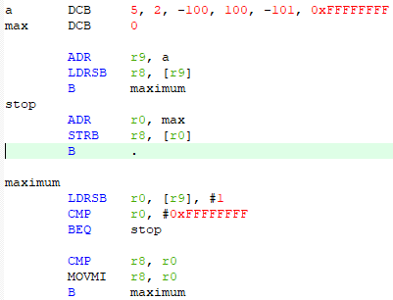

3.4. (10 p.) Write a subroutine that adds two 64-bit variables. The first number is declared in the memory under the label first (two words, the first is the most significand), the second has a label second.
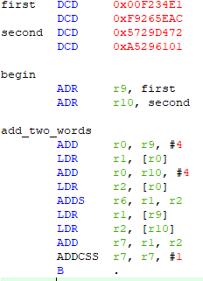

3.5. (5 p.) Assume that an ASCII character is loaded in r5. Write a subroutine that increments a counter if the character is a letter.
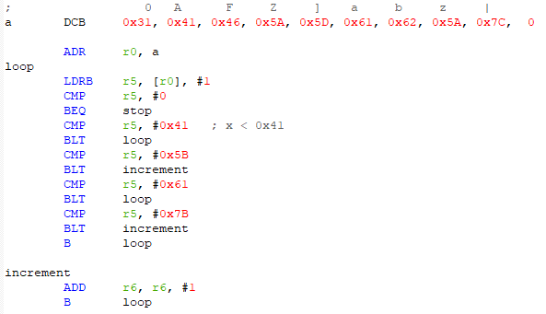

3.6. Draw a block diagram, write and debug a subroutine, which counts the number of 0s in a word, located in the memory.
You are supposed to invent an algorithm, where the passes through the loop are equal to the number of 0s. For example, if the half word is 173F₍₁₆₎ your loop has to run 6 times and the count of 0s has to be 6 .
(Hint: First significant operation in the loop should be increment (add 1) the given word. What is the next? Read again about logical operations!!!) Please, do not count the number of 1s and then subtract from 32!

